***Notes for Numerical Integration – Trapezoidal Rule and Sums***

ESSENTIAL QUESTION: What is the advantage to using areas of trapezoids vs areas of rectangles for

estimating the value of a definite integral?

Recall that the area of a trapezoid is .  can be approximated using the sum of the areas of trapezoids in the same manner that we found Riemann sums.

**DERIVE THE TRAPEZOIDAL RULE:**

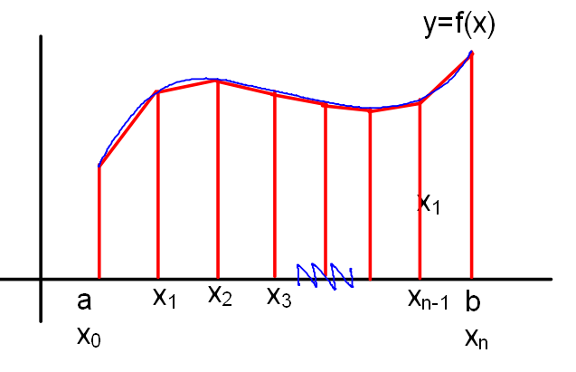

***The Trapezoidal Rule***: Let  be continuous on [*a, b*]. Then

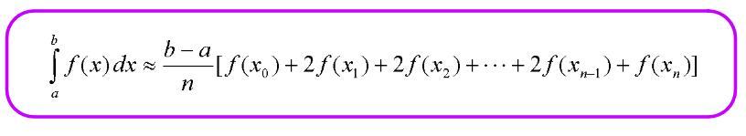

NOTE: **The Trapezoidal Rule only applies if the partitions have equal width!!!!!** If the widths are not equal, we’ll do a TRAPEZOIDAL SUM – find the area of each trapezoid and add ‘em up!

Examples:

1. Use the Trapezoidal Rule with 4 equal partitions to approximate the value of .
2. Use the Trapezoidal Rule with *n* = 4 to estimate the value of .

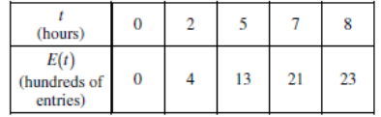 ***Why does this problem require a trapezoidal sum?***

A zoo sponsored a one-day contest to name a new baby elephant. Zoo visitors deposited entries in a special box between noon (t = 0) and 8 p.m. (t = 8). The number of entries in the box t hours after noon is modeled by a differentiable function E for . The values of , in hundreds of entries, at various times t are shown in the table above. Use a trapezoidal sum with the four subintervals given by the table to approximate the value of . Using correct units, explain the meaning of  in terms of the number of entries.