**Honors Precalculus Notes for Graphing Piecewise Functions**

Piecewise functions are those functions that are defined by multiple sub-functions for different intervals of x. The absolute value function is commonly defined as a piecewise function:

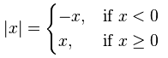

Here are some examples for how to graph piecewise functions.

|  |  |
| --- | --- |
|  |  |
|  | 5x5plan |

|  |  |
| --- | --- |
|  |  |
|  |  |
|  | 5x5plan |

<http://www.coolmath.com/precalculus-review-calculus-intro/precalculus-algebra/07-graphing-piecewise-defined-functions-03>

**Evaluating Piecewise Functions**

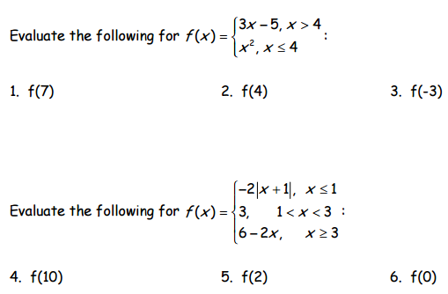

**Writing Piecewise Equations**

|  |  |
| --- | --- |
|  |  |
|  |  |