NOTES FOR CIRCLES
A circle is the set of all points that are equidistant from a fixed point, called the center.

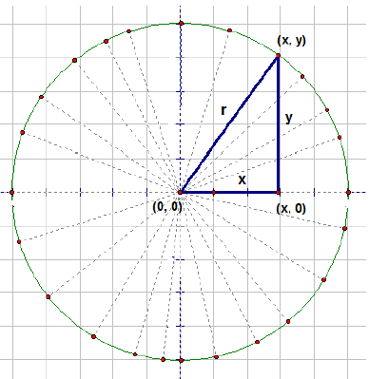 | Derive a general equation for a circle with its center at the origin and with radius r.

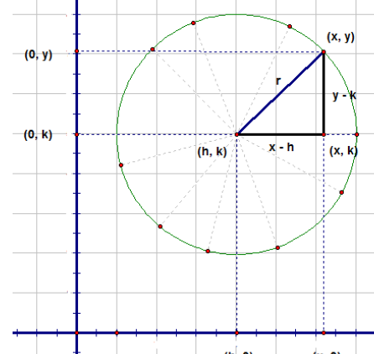 | Derive a general equation for a circle with its center at (h, k) and with radius r.

Write equations for the following circles in standard form (x – h)² + (y – k)² = r²
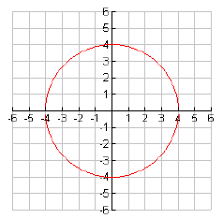 | 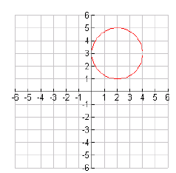

Rewrite the equations of circles in standard form (x – h)² + (y – k)² = r².
x² + y² + 2x + 4y = 20 | x² + y² - 9y = 0 | 2x² + 2y² - 12x + 8y – 24 = 0

Intersections of Circles, Lines, and Parabolas
Sketch a graph for each pair of equations. Find the exact points of intersection.
x² + y² = 16  y= 4x | 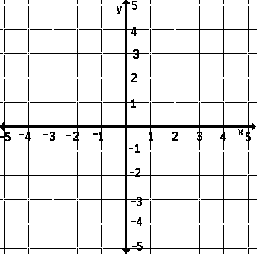 | Solution:
y = 4 – x²  x²+ (y – 4)² = 16 |  | Solution:
x² + y² = 4  (x + 3)²+ y ² = 9 |  | Solution:
THE ULTIMATE BONUS PROBLEM (Non-linear systems involving circles)
A circle passes through the points (-13, -2), (-1, 16), and (4, 15). Write an equation for this circle in standard form.

Here’s another one to practice on….same directions: (-2, 0), (2, -2), and (5, 7)

