AP CALCULUS AB MIDTERM REVIEW NAME

***NO CALCULATORS***

|  |  |
| --- | --- |
| 1. Find . | 2. Find . |
| 3. Find  if | 4. Find  if . |
| 5. Find  if . | 6. Find  if . |
| 7. In the *xy*-plane, the line , where *k* is a constant, is tangent to . What is the value of *k*. | 8. Determine the slope of the tangent to  at the point (3, 1). |
| 9. If , find the *x*-coordinate  of the local minimum of . (You’ll need a calculator for this one.) | 10. If  then |
| 11.  Which of the following is (are) true?   1. *f* has a limit at *x* = 2. 2. *f* is continuous at *x* = 2. 3. *f* is differentiable at *x* = 2. | 12.  Let *f* be the function defined above, where *c* and *d* are constants. If *f* is differentiable at *x* = 2, what is the value of *c + d*? |

***INTERPRET THE GRAPHS***

|  |  |
| --- | --- |
| **Given the graph of  at the right.**  13. Which limit(s) exist?  A.  B.  C.  D.  14. At what value(s) of *x* is  undefined?  15. For which value of *x* is  negative and decreasing?  A. -4 B. -2 C. 0 D. 3 E. 4 |  |
| **Given the graph of  at the right.**  16. At what x-value does  have a relative maximum?  A relative minimum? Justify your answer.  17. On what interval(s) is  concave up? Justify.  18. For what value(s) of x does  have a point of  inflection? Justify. |  |
| **Given the graph of  at the right.**  19. On what interval(s) is  concave down? Justify your  answer. |  |
| 20. For the graph of  at the right, at which point is  and ? |  |

***CALCULATOR ACTIVE***

* ***Position***: ***x(t)*** refers to where a particle is located on the *x*-axis at a given time *t*.
* ***Average velocity***: ******(Note: This is also ***average rate of change*** of a function on an interval.)
* ***Velocity***:  determines the rate at which the position is changing at time *t*, as well as the direction of the movement. If , the particle is either moving up or right. If , the particle is moving down or left.
* ***Acceleration***:  determines the rate at which the velocity is changing at time t. The sign of acceleration indicates whether the velocity is increasing or decreasing.

21. A particle moves along the *x*-axis so that at time *t* its position is given by 

1. At *t* = 0, is the particle moving to the right or to the left? Explain your answer.
2. At *t* = 1, is the velocity of the particle increasing or decreasing? Explain your answer.
3. Find all values of *t* for which the particle is moving to the left.

22.

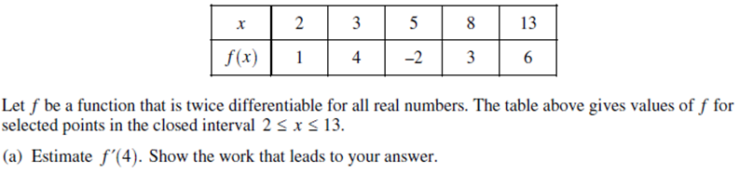

23.

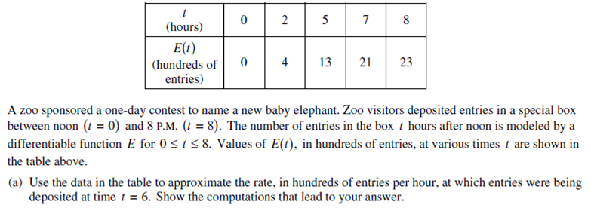

24. A 25-foot ladder is leaning against a house. The base of the ladder begins to slide away from the house at a rate of 2 feet per second.

a. At what rate is the top of the ladder moving down the house when it is 24 feet from the ground?

b. The house, the ladder, and the ground form a right triangle. At what rate is the area of the triangle

changing at the instant described in (a)?

1. At what rate is the angle between the ladder and the ground changing at the instant described in (a)?

25. Find the dimensions of a closed box with square base with:

1. volume 12 cubic meters and minimum surface area.

b. surface area 20 square meters and maximum volume.