AP CALCULUS AB EXAM REVIEW
LIMITS & CONTINUITY
NO CALCULATOR

1. | 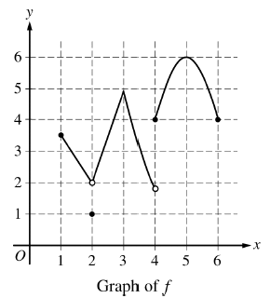 | 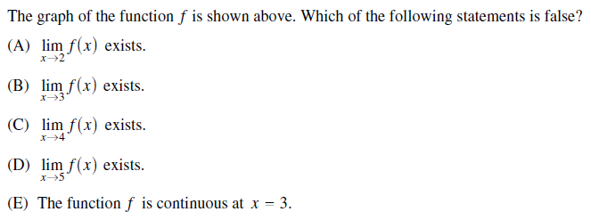
2. | 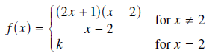 | 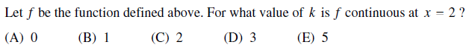
3. | 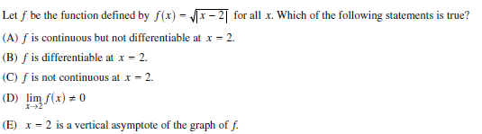
4. | 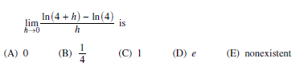
5. | 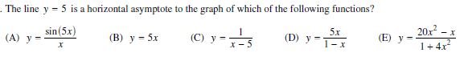
6. | 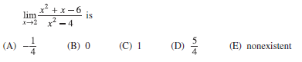
7. | 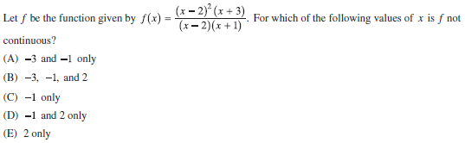

8. | 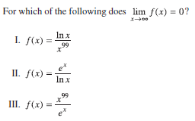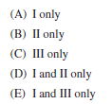
9. | 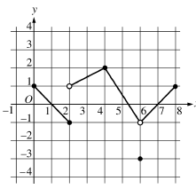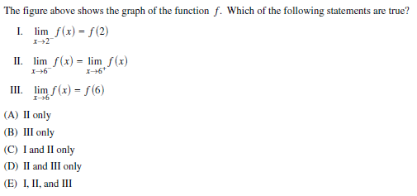
10. | 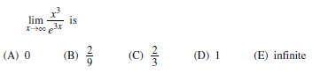
11. | 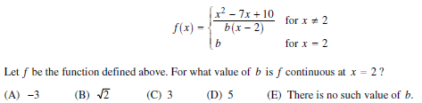
12. | 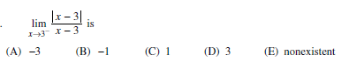

13. | 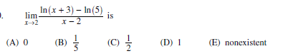
14. | 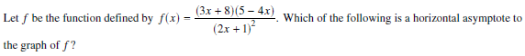  (A) y = -6 (B) y = -3 (C) y = -1/2 (D) y = 0 (E) y = 3/2
ANSWERS
- C
- E
- A
- B
- E
- D
- D
- E
- C
- A
- E
- B
- B
- B

