**REVIEW: DERIVATIVES AND THEIR APPLICATIONS**

***LIMIT DEFINITION OF DERIVATIVE***

, or if  

***DERIVATIVES ARE RATES OF CHANGE***

Consider  on the interval [*a, b*], with some point *x = c* in the interval.

Average rate of change of  =  (also average velocity)

Instantaneous rate of change at *x = c* is . (also instantaneous velocity)

***DERIVATIVE RULES***

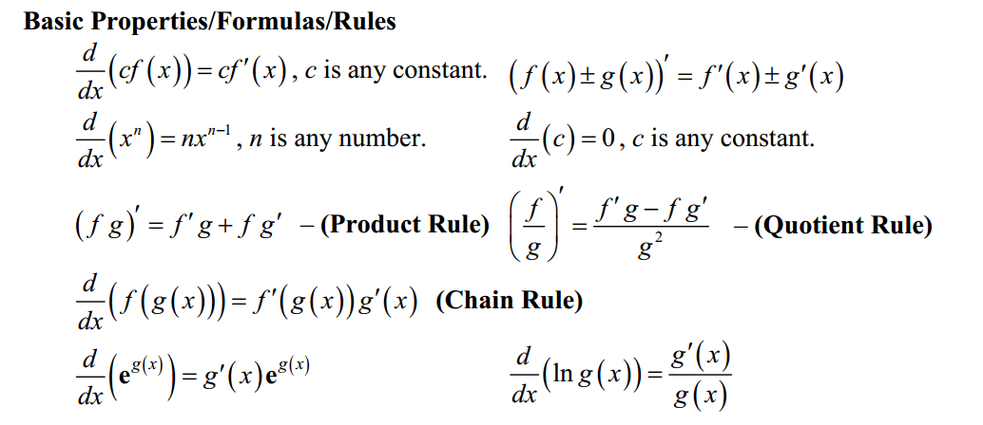

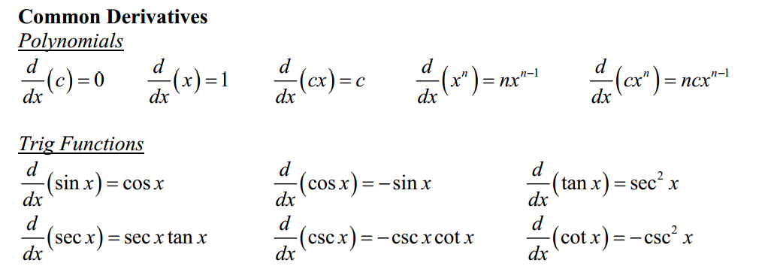

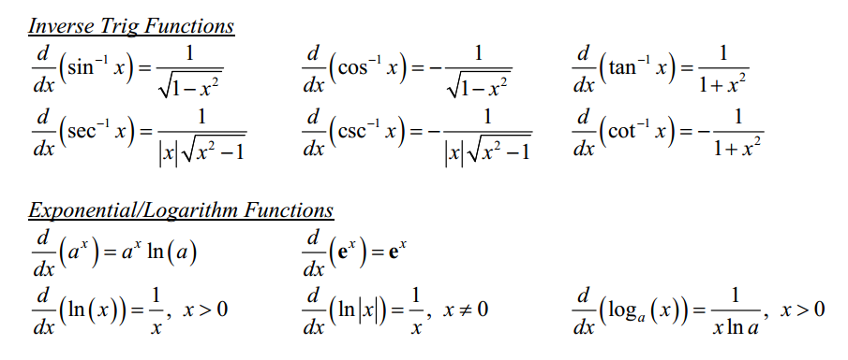

***MOTION UNDER GRAVITY: FREE-FALLING BODIES***

Position: 

,  is initial velocity (negative if moving down),

 is initial position with respect to the ground.

Velocity: 

Acceleration: 

***IMPLICIT DIFFERENTIATION: Use when equation is not easily solvable for y, or when differentiating with respect to time.***

If , the derivative is found as follows. Remember product rule!









***DERIVATIVE OF at x = a.***



***APPLICATIONS***

**1.** **Linear approximation:** Write the equation of the line tangent to at a point .

Remember that the slope of the tangent is . Use the tangent line to approximate the value

of  for some *x* near .

2. **Differentials:** The differential of *y* is . Add *dy* to  to approximate  at

a point near .

**3.** **Related Rates:** This is an application of implicit differentiation with respect to time *t*. To set up

related rates problems, try asking yourself these questions?

* 1. Identify what you know.
  2. Identify what you’re looking for.
  3. Think of how you can connect the known to the unknown.
  4. Write an equation.
  5. If the equation contains more than 2 variables, look for a relationship that will eliminate one of the variables.
  6. Differentiate the simplified equation implicitly with respect to time (*t*).
  7. Substitute the known information into the derivative. Solve for the unknown.
  8. Be sure to include units.

**4.** **Optimization:** Find the maximum or minimum value of a function given certain restrictions.

* 1. Identify what you know.
  2. Identify what you’re looking for.
  3. Write a primary equation for the quantity that you want to maximize or minimize.
  4. Write a secondary equation (if necessary) that will allow you to rewrite the primary equation so that it has no more than 2 variables.
  5. Find the derivative of the primary equation, set the derivative = 0, and find the critical numbers.
  6. Apply the First Derivative Test to determine whether the critical numbers give a min or a max.
  7. Also consider whether the critical numbers make sense in the context of the problem.
  8. Re-read the question and answer appropriately. Include units.

**5. Motion:** In addition to free-falling bodies, motion can be modeled by any function. Some things to remember about motion:

1.  means an object is moving up (or right).  means the object is moving down (or left).
2. Speed =  if an equation is in rectangular form. If an equation is in parametric form, then speed = .
3. Speed is increasing if velocity and acceleration have the same sign for a certain value of *t*.

**6. Mean Value Theorem for Derivatives**

If  is continuous on [a, b] and differentiable on (a, b), then there is at least one c, , such that .

* This means that for at least one c in (a, b), the instantaneous rate of change at x = c is the same as the average rate of change on the interval.
* Another way to interpret this is that the slope of at least one tangent line to  will equal the slope of the secant line through the endpoints of the interval.

**7. Using the derivative to analyze the graph of behavior of a function:**

|  |  |
| --- | --- |
| **The behavior of** | **...indicates this behavior in** |
| or  is undefined | *x = c* is a critical number. There is a possible max or min at *x = c*.  If  changes from positive to negative, there is a max at *x = c*.  If  changes from negative to positive, there is a min at *x = c*. |
|  | is increasing (or moving right).  is decreasing (or moving left). |
| is increasing  is decreasing | is concave up.  is concave down. |

|  |  |
| --- | --- |
| **The behavior of** | **...indicates this behavior in** |
| or  is undefined | has a point of inflection at *x = c* if  changes sign on either side of *x = c*. |
|  | is concave up.  is concave down. |
| and... | has a relative min at *x = c*.  has a relative max at x = c. |

**Remember, if you are asked to find ABSOLUTE EXTREMA, find the local extrema, but also look at the value of  at the endpoints of the interval!**