Honors Precalculus Name
Circles Assignment

1. Write an equation in standard form for the circle that is graphed below.  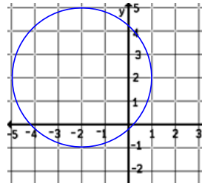 | 2. Rewrite the equation of circle in standard form  (x – h)² + (y – k)² = r².  3x² + 3y² – 24y – 27 = 0
3. Rewrite the equation of circle in standard form.  5x² + 5y² + 20y – 10x = 20 | 4. Sketch a graph and solve the system algebraically.  Give exact answers.  x² + y² = 4  x – 2y = 2  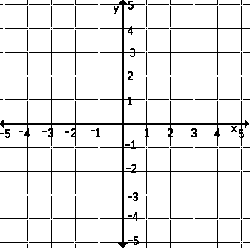
5. Sketch a graph and solve the system algebraically.  Give exact answers.  x² + y² = 9  y = x² – 2 | 6. Sketch a graph and solve the system algebraically.  Give exact answers.  y = 1 + 2x – x²  y = 1 – x
7. Write an equation of the parabola with focus (-5, 3)  and vertex (-5, 6). Graph the parabola. | 8. Write an equation of the parabola with focus (2, -3)  and directrix x = 5. Graph the parabola.

