Angles of Elevation & Depression
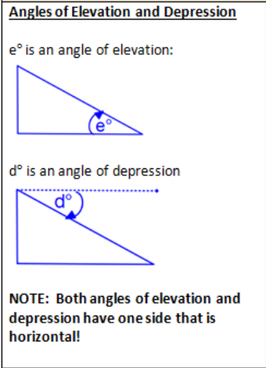 | - The angle of depression is 6° from the top of a lighthouse 130 feet above the water to a buoy in the Atlantic Ocean. Find the distance from the base of the lighthouse to the buoy.  - From the top of a 100-ft tall building, Joe observes a car moving toward the building. If the angle of depression changes from 22° to 46°, how far did the car travel?  - A large helium-filled penguin is at the beginning of the Thanksgiving Day Parade in Charlotte. Two cables attached to the penguin make angles of 48° and 40° with the ground and are anchored 10 feet from each other. How high is the penguin above the ground?

