Unit Circle Practice Name ___________________________________________

**A UNIT CIRCLE is a circle with radius 1. We'll use this fact and revised versions of our master 45-45-90 and 30-60-90 triangles to find trig values on the unit circle.**

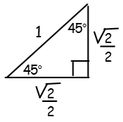 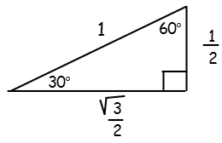

|  |  |
| --- | --- |
| 1. Label the axes angles in degrees and radians. Label the coordinates of the 4 points on the unit circle that are on the coordinate axes. | 2. Label the angles that are multiples of 45° ( π/4). Then sketch a first quadrant reference triangle. Label the coordinates of all of the points on the unit circle that are on angles that are multiples of π/4. |

|  |  |
| --- | --- |
| 3. Label the angles that are multiples of 30° (π/6). Then sketch a first quadrant reference triangle. Label the coordinates of all of the points on the unit circle that are on angles that are multiples of π/6. | 4. Label the angles that are multiples of 60° (π/3). Then sketch a first quadrant reference triangle. Label the coordinates of all of the points on the unit circle that are on angles that are multiples of π/3. |

**Now compile all of this data onto a single unit circle.**

**Every point (x, y) on the unit circle gives the value of (cos θ, sin θ).**

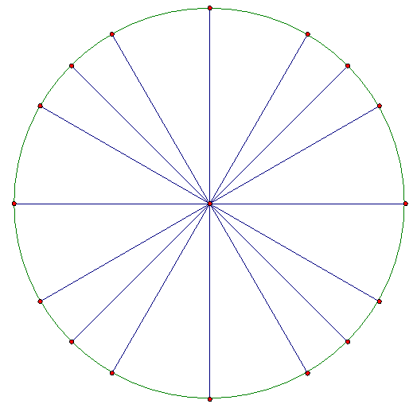

**Use your unit circle to evaluate the following. Simplify your answers!**

**Remember that these identities will help you!**

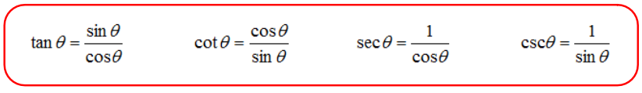

1.  2.  3. 

4.  5.  6. 

7.  8.  9. 

10.  11.  12. 

13.  14.  15. 